Dear NAME,
I'm writing to you on behalf of our Food Drive benefiting Katy Christian Ministries (KCM). KCM’s mission is to reduce the effects of food insecurity in our community by creating a network of local partners and supporters dedicated to sustainability.
We ask for your help in this mission by donating and spreading awareness about our Food Drive. Your generous contribution will benefit people across our community who are struggling with hunger.
Last year KCM distributed 1,381,900 meals to families in our community. This year the need is even greater.
Your support will bring us one step closer to fighting food insecurity. So, please consider donating today and sharing our campaign on your social media channels!
Thank you for taking the time to read this message, and if you have any questions, please contact me directly. I look forward to hearing from you soon!
Sincerely, YOUR NAME

OPTIONAL:

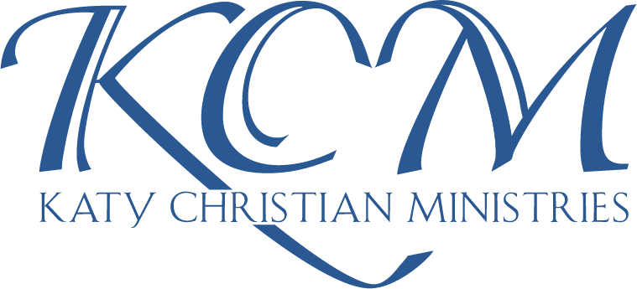
For more information on the good work KCM does in our community, please visit.
https://ktcm.org/impact

